TC-CSC-003
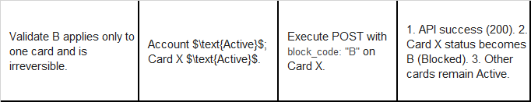
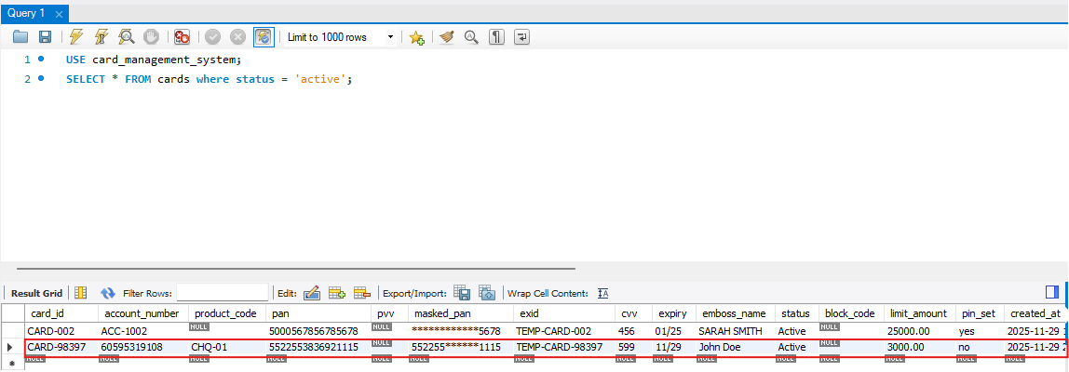
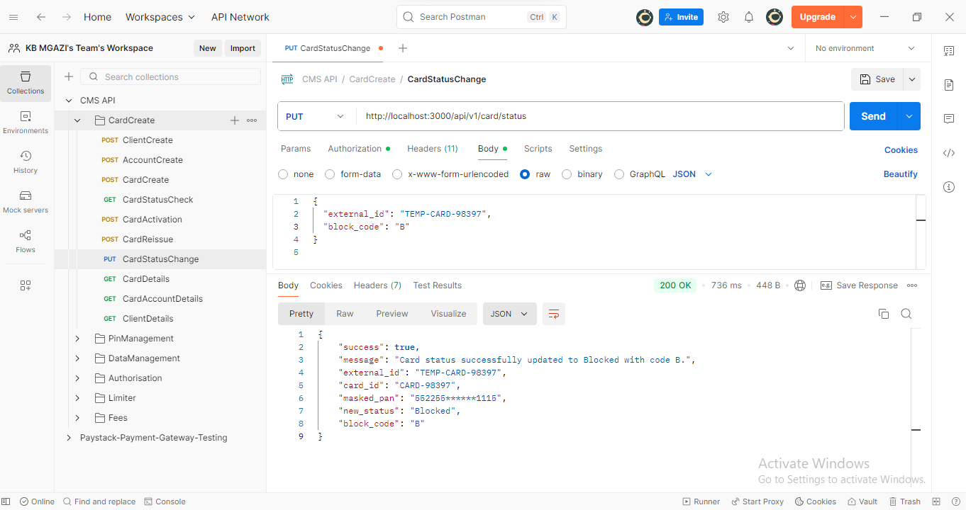
Request:
{
"external_id": "TEMP-CARD-98397",
"block_code": "B"
}

Response:
{
"success": true,
"message": "Card status successfully updated to Blocked with code B.",
"external_id": "TEMP-CARD-98397",
"card_id": "CARD-98397",
"masked_pan": "552255******1115",
"new_status": "Blocked",
"block_code": "B"
}

